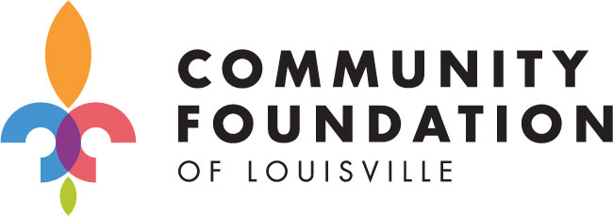
Grant Opportunities Offered or Hosted by the Community Foundation of Louisville
The Community Foundation of Louisville hosts grant opportunities for a number of its affiliate foundations located in rural parts of the state; for several donor funds; and, for the foundation’s unrestricted funds (Fund for Louisville).
In 2020, the Foundation celebrated awarding more than $2.5 million in capacity building grants to nonprofit organizations in Louisville from the Fund for Louisville, including a three-year focus on awarding grants to organizations doing significant work in parts of Louisville most impacted by longstanding disinvestment and underinvestment. As of January 2020, the strategy to inform the next Fund for Louisville grant cycle is in development. Once finalized, information will be shared via email with nonprofit organizations in Louisville and via the Foundation’s eNews.
This document summarizes information current grant opportunities, but is subject to change. When grant applications are open, you may find them on the Foundation’s grant application site: https://www.grantinterface.com/Home/Logon?urlkey=cflouisville.

Application Open Periods
January | February | March | April | May | June | July | August | September | October | November | December
Field of Interest Fund Grants
2020 Food System Fellowship |  |  |  |  |  |  |  |  | Green River Area Community Fdtn
Artemis Fund |  |  |  |  | Oldham County Community Fdtn

Artemis Fund
Overview: The Artemis Fund is a donor-advised fund with the Community Foundation of Louisville administered entirely by high school students who are enrolled in a philanthropy course at Kentucky Country Day School. The Fund awards grants to local organizations working in Greater Louisville to support youth issues or promote youth development.
Application Period: Online application in January.
Amount Awarded: Several grants totaling approximately $6,000 each year.
For more information: https://www.kcd.org/page/the-artemis-fund
Field of Interest Grants
Overview: Field of Interest Funds support organizations working within a specific geographic region; toward a specific purpose, such as supporting the arts or education; or with a specific population, such as children or the elderly. Each Fund was established by a donor with a specific charitable purpose in mind and, in perpetuity, CFL will continue to support the issues that the donor cared about most.
Application Period: Online application in January.
Amount Awarded: Several grants totaling $10,000-$15,000 each year (varies each year).
For more information: https://www.cflouisville.org/grants-partnerships/field-of-interest-grants/
Food System Fellowship
Overview: Funding for learning experiences that advance one or more opportunities identified by local food system leaders to strengthen Louisville’s food system.
Application Period: Online application open from January 6 to February 17, 2020
Amount Awarded: Two stages of funding; please see “Food System Fellowship Information Packet” at link below.
For more information: https://www.cflouisville.org/grants-partnerships/hunger-innovation-fellowship/
Oldham County Community Foundation
Overview: The Oldham County Community Foundation, an affiliate of the Community Foundation of Louisville, provides grants to help Oldham County nonprofits improve their work.
Application Period: Online application open: June. Due: August. Grantees Announced: September. Amount Awarded: 10-15 grants totaling approximately $20,000 each year.
For more information: https://www.cflouisville.org/about/oldham-county-community-foundation/
Green River Area Community Foundation
Overview: The Green River Area Community Foundation, an affiliate of the Community Foundation of Louisville, offers capacity building grants from its Owensboro-Daviess County Community Fund to nonprofits working in Daviess County.
Application Period: Online application opens: September. Due: November. Grantees Announced: Jan.
Amount Awarded: Several grants totaling approximately $20,000 each year
For more information: https://cfl.iphiview.com/cfl/

